

Use Case Specification: CSR eCL Notification
For
eCoaching Log

Change History Log

Date | Version | Description | Author
08/18/2014 | 1.0 | Initial Document | Doug Stearns
9/09/2014 | 1.1 | Corrected text for Pending Acknowledgement, updates from review and phase 2 development | Doug Stearns
09/23/2014 | 1.2 | P13515 – eMail Mappings  Revised 4.8, 4.13, Figure 2, Figure 3 to reflect copy of email sent to Supervisor when status is Pending Acknowledgement | Doug Stearns
10/07/2014 | 1.3 | P13479 – eCL CSR Warnings  Added Progressive Disciplinary Warning to 3.2 and added 4.8 Pending Employee Review | Doug Stearns
09/14/2015 | 1.4 | TFS644 – eCL Inappropriate ARC Feed  Added alternate flows 4.18 and 4.19  Updated Figure 3 | Doug Stearns
9/27/2015 | 1.4 | TFS644 – eCL Inappropriate ARC Feed  Updates as a result of review.4.18, 4.19 Page 13 | Doug Stearns
9/27/2015 | 1.4 | TFS644 – eCL Inappropriate ARC Feed  Updates as a result of review.4.18, 4.19 Page 13 | Doug Stearns
11/12/2015 | 1.5 | 864:eCoaching - Open CSR Comments field on all eCLs 4.5.5 and 4.10.5 | Lisa Stein
Table of Contents

1. Brief Description 6
2. Participating Actors 6
2.1 Primary 6
2.2 Secondary 6
3. Basic Flow of Events 7
3.1 System generates eCoaching eMail notification. 7
3.2 Employee (CSR) receives system generated eMail notification of eCoaching Log when coaching is Direct, is not a Customer Service Escalation or Progressive Disciplinary Warning, opportunity identified something other than Quality Specialist Coaching, and status is Pending Employee Review, then the eMail notification will use the following: 7
3.3 Employee (CSR) selects hyper link to eCoaching Log Dashboard. 7
3.4 Employee (CSR) selects appropriate eCoaching Log to review. 7
3.5 Employee (CSR) selects acknowledgement of the coaching opportunity (required). 7
3.6 Employee (CSR) enters desired comments (free form text up to 3000 characters). 7
3.7 Employee (CSR) submits the acknowledgement. 7
3.8 Status of eCoaching Log becomes Completed. 7
4. Alternative Flows 8
4.1 Pending Employee Review. [Step 3.2] 8
4.2 Pending Manager Review. [Step 3.2] 8
4.3 Pending Manager Review. [Step 4.2.4] 8
4.4 Pending Employee Review. [Step 3.2] 8
4.5 Pending Supervisor Review. [Step 3.2] 9
4.6 Pending Manager Review. [Step 3.2] 9
4.7 Pending Manager Review. [Step 4.6.4] 10
4.8 Pending Employee Review. [Step 3.2] 10
4.9 Outlier Pending Acknowledgement [Step 3.2] 10
4.10 Outlier Pending Employee Review [Step 3.2] 11
4.11 Outlier Pending Supervisor Review. [Step 3.2] 11
4.12 Outlier Pending Manager Review. [Step 3.2] 11
4.13 Outlier Pending Manager Review. [Step 4.11.4] 12
4.14 Quality Pending Acknowledgement [Step 3.2] 12
4.15 Quality Pending Supervisor Review. [Step 3.2] 13
4.16 Quality Pending Manager Review. [Step 3.2] 13
4.17 Quality Pending Manager Review. [Step 4.15.4] 14
4.18 Outlier Pending Supervisor Review – IAE, IAT. [Step 4.11] 14
4.19 Quality Pending Supervisor Review. [Step 4.18.4] 14
5. Preconditions 15
5.1 eCoaching Log for Supervisor successfully submitted. 15
5.2 System generated eMail notification sent to appropriate parties. 15
5.3 eCoaching Log database populated with correct and current hierarchy information for CSRs, Supervisors, Managers. 15
6. Postconditions 15
6.1 eCoaching Log reviewed and acknowledged by Employee (CSR). 15
6.2 eCoaching Log reviewed and acknowledged by Supervisor. 15
6.3 eCoaching Log reviewed and acknowledged by Manager. 15
7. Assumptions and Dependencies 15
7.1 Access to CSR module will be limited to those with the following job codes. 15
7.2 Basic from of eMail notification is as follows: 15
8. Business Rules 16
8.1 none 16
9. Technical Requirements 16
9.1 none 16
10. Activity Diagrams 17

Table of Figures
Figure 1 – CSR eCL Notification 18
Figure 2 – CSR eCL Notification – Outlier 19
Figure 3 – CSR eCL Notification – IQS/Outlier 20

Brief Description
eCoaching Log notifications and acknowledgment for Supervisors.

Participating Actors

Primary

CSR

Supervisors

Secondary

Managers

Outliers

Quality

Basic Flow of Events

System generates eCoaching eMail notification.

Employee (CSR) receives system generated eMail notification of eCoaching Log when coaching is Direct, is not a Customer Service Escalation or Progressive Disciplinary Warning, opportunity identified something other than Quality Specialist Coaching, and status is Pending Employee Review, then the eMail notification will use the following:

Subject:
eCL: Pending Employee Review (<EMPLOYEE NAME>))
Message:
A new eCoaching Log has been entered on your behalf. Please click on the link below to review and verify the coaching opportunity received on <DATE>.

Employee (CSR) selects hyper link to eCoaching Log Dashboard.

Employee (CSR) selects appropriate eCoaching Log to review.

Employee (CSR) selects acknowledgement of the coaching opportunity (required).

Employee (CSR) enters desired comments (free form text up to 3000 characters).

Employee (CSR) submits the acknowledgement.

Status of eCoaching Log becomes Completed.

Alternative Flows

Pending Employee Review. [Step 3.2]

No eMail notification is generated for an eCoaching Log when the coaching is Direct, is not a Customer Service Escalation, opportunity identified as Quality Specialist Coaching.

Status of eCoaching Log becomes Completed.

Pending Manager Review. [Step 3.2]

Manger receives system generated eMail notification of eCoaching Log when coaching is Direct, is a Customer Service Escalation, opportunity identified as something other than Manager Coaching, and status is Pending Manager Review then the eMail notification will use the following:
Subject:
eCL: Pending Manager Review (<EMPLOYEE NAME>)
Message:
A new eCoaching Log has been entered and requires your action. Please click on the link below to review and verify that the eCL entered on <DATE > for <EMPLOYEE NAME> is a valid Customer Service Escalation (CSE). Further directions are provided on the form.

Manager selects the hyper link to eCoaching Log Dashboard.

Manager selects the appropriate eCoaching Log to review.

Manager selects Yes to confirm it is a Customer Service Escalation (required).

Manager selects or enters date coached (required).

Manager enters coaching detail (required; free form text up to 3000 characters).

Manager submits eCoaching Log review.

Status of eCoaching Log becomes Pending Supervisor Review.

Pending Manager Review. [Step 4.2.4]

Manager selects No to confirm it is not a Customer Service Escalation (required).

Manager selects or enters date reviewed (required).

Manager enters reason not a Customer Service Escalation (required; free form text up to 3000 characters).

Continue with step 4.2.7 above.

Pending Employee Review. [Step 3.2]

Employee (CSR) receives system generated eMail notification of eCoaching Log when coaching is Direct, is a Customer Service Escalation, opportunity identified as Manager Coaching, and status is Pending Employee Review then the eMail notification will use the following:
Subject:
eCL: Pending Employee Review (<EMPLOYEE NAME>)
Messge:
A new eCoaching Log has been entered on your behalf. Please click on the link below to review and verify the coaching opportunity received on <DATE>.

Employee (CSR) selects the hyper link to eCoaching Log Dashboard.

Employee (CSR) selects the appropriate eCoaching Log to review.

Employee (CSR) selects acknowledgement of the coaching opportunity (required).

Employee (CSR) enters desired comments (free form text up to 3000 characters).

Employee (CSR) submits the acknowledgement.

Status of eCoaching Log becomes Completed.

Pending Supervisor Review. [Step 3.2]

Supervisor receives system generated eMail notification of eCoaching Log when coaching is Indirect, is not a Customer Service Escalation and status is Pending Supervisor Review then the eMail notification will use the following:
Subject:
eCL: Pending Supervisor Review (<EMPLOYEE NAME>)
Message:
A new eCoaching Log has been entered on behalf of <EMPLOYEE NAME> on <DATE> that requires your action. Please click on the link below to review the eCoaching log.

Supervisor selects the hyper link to eCoaching Log Dashboard.

Supervisor selects the appropriate eCoaching Log to review.

Supervisor selects or enters date coached (required).

Supervisor enters coaching detail (required; free form text up to 3000 characters).

Supervisor submits eCoaching Log review.

Status of eCoaching Log becomes Pending Employee Review.

Pending Manager Review. [Step 3.2]

Manger receives system generated eMail notification of eCoaching Log when coaching is Indirect and is a Customer Service Escalation and status is Pending Manager Review then the eMail notification will use the following:
Subject:
eCL: Pending Manager Review (<EMPLOYEE NAME>)
Message:
A new eCoaching Log has been entered and requires your action. Please click on the link below to review and verify that the eCL entered on <DATE> for <EMPLOYEE NAME> is a valid Customer Service Escalation (CSE). Further directions are provided on the form.

Manager selects the hyper link to eCoaching Log Dashboard.

Manager selects the appropriate eCoaching Log to review.

Manager selects Yes to confirm it is a Customer Service Escalation (required).

Manager selects or enters date coached (required).

Manager enters coaching detail (required; free form text up to 3000 characters).

Manager submits eCoaching Log review.

of eCoaching Log becomes Pending Supervisor Review.

Pending Manager Review. [Step 4.6.4]

Manager selects No to confirm it is not a Customer Service Escalation (required).

Manager selects or enters date reviewed (required).

Manager enters reason not a Customer Service Escalation (required; free form text up to 3000 characters).

Continue with step 4.6.7 above.

Pending Employee Review. [Step 3.2]

No eMail notification is generated for an eCoaching Log when the coaching is Direct, is a Progressive Disciplinary Warning.

Status of eCoaching Log becomes Completed.

Outlier Pending Acknowledgement [Step 3.2]

Employee (CSR) receives system generated eMail notification of eCoaching Log when coaching is Indirect from Outlier Data Feed, is not a Customer Service Escalation, and status is Pending Acknowledgement, then the eMail notification will use the following:

Subject:
eCL: Pending Acknowledgement (<EMPLOYEE NAME>)
Message:
A new eCoaching Log has been entered on your behalf. Please click on the link below to review and verify the coaching opportunity received on <DATE>.

Supervisor receives a copy of the eMail notification.

Employee (CSR) selects hyper link to eCoaching Log Dashboard.

Employee (CSR) selects appropriate eCoaching Log to review.

Employee (CSR) selects acknowldegement (required).

Employee (CSR) enters desired comments (free form text up to 3000 characters).

Employee (CSR) submits the acknowledgement.

Status of eCoaching Log becomes Completed.

Outlier Pending Employee Review [Step 3.2]

Employee (CSR) receives system generated eMail notification of eCoaching Log when coaching is Indirect from Outlier Data Feed, is not a Customer Service Escalation, and status is Pending Employee Review, then the eMail notification will use the following:

Subject:
eCL: Pending CSR Review (<EMPLOYEE NAME>)
Message:
A new eCoaching Log has been entered on your behalf. Please click on the link below to review and verify the coaching opportunity received on <DATE>.

Employee (CSR) selects hyper link to eCoaching Log Dashboard.

Employee (CSR) selects appropriate eCoaching Log to review.

Employee (CSR) selects acknowledgement of the coaching opportunity (required).

Employee (CSR) enters desired comments (free form text up to 3000 characters; (required).

Employee (CSR) submits the acknowledgement.

Status of eCoaching Log becomes Completed.

Outlier Pending Supervisor Review. [Step 3.2]

Supervisor receives system generated eMail notification of eCoaching Log when coaching is Indirect from Outlier Data Feed, is not a Customer Service Escalation, and status is Pending Supervisor Review then the eMail notification will use the following:
Subject:
eCL: Pending Supervisor Review (<EMPLOYEE NAME>)
Message:
A new eCoaching Log has been entered on behalf of <EMPLOYEE NAME> on <DATE > that requires your action. Please click on the link below to review the eCoaching log.

Supervisor selects the hyper link to eCoaching Log Dashboard.

Supervisor selects the appropriate eCoaching Log to review.

Supervisor selects or enters date coached (required).

Supervisor enters coaching detail (required; free form text up to 3000 characters).

Supervisor submits eCoaching Log review.

Status of eCoaching Log becomes Pending Employee Review.

Outlier Pending Manager Review. [Step 3.2]

Manger receives system generated eMail notification of eCoaching Log when coaching is Indirect from Outlier Data Feed and is a Customer Service Escalation and status is Pending Manager Review then the eMail notification will use the following:
Subject:
eCL: Pending Manager Review (<EMPLOYEE NAME>)
Message:
A new eCoaching Log has been entered and requires your action. Please click on the link below to review and verify that the eCL entered on <DATE> for <EMPLOYEE NAME> is a valid Customer Service Escalation (CSE). Further directions are provided on the form.

Manager selects the hyper link to eCoaching Log Dashboard.

Manager selects the appropriate eCoaching Log to review.

Manager selects Yes to confirm it is a Customer Service Escalation (required).

Manager selects or enters date coached (required).

Manager enters coaching detail (required; free form text up to 3000 characters).

Manager submits eCoaching Log review.

of eCoaching Log becomes Pending Manager Review.

Outlier Pending Manager Review. [Step 4.11.4]

Manager selects No to confirm it is not a Customer Service Escalation (required).

Manager selects or enters date reviewed (required).

Manager enters reason not a Customer Service Escalation (required; free form text up to 3000 characters).

Continue with step 4.11.7 above.

Quality Pending Acknowledgement [Step 3.2]

Employee (CSR) receives system generated eMail notification of eCoaching Log when coaching is Indirect from Quality Data Feed, is not a Customer Service Escalation, and status is Pending Acknowledgement, then the eMail notification will use the following:

Subject:
eCL: Pending Acknowledgement (<EMPLOYEE NAME>)
Message:
A new eCoaching Log has been entered and requires your action. Please click on the link below to review and acknowledge the eCL entered on <DATE>.

Supervisor receives a copy of the eMail notification.

Employee (CSR) selects hyper link to eCoaching Log Dashboard.

Employee (CSR) selects appropriate eCoaching Log to review.

Employee (CSR) selects acknowledgement (required).

Employee (CSR) enters desired comments (free form text up to 3000 characters).

Employee (CSR) submits the acknowledgement.

Status of eCoaching Log becomes Completed.

Quality Pending Supervisor Review. [Step 3.2]

Supervisor receives system generated eMail notification of eCoaching Log when coaching is Indirect from Quality Data Feed, is not a Customer Service Escalation, and status is Pending Supervisor Review then the eMail notification will use the following:
Subject:
eCL: Pending Supervisor Review (<EMPLOYEE NAME>)
Message:
A new eCoaching Log has been entered on behalf of <EMPLOYEE NAME> on <DATE> that requires your action. Please click on the link below to review the eCoaching log.

Supervisor selects the hyper link to eCoaching Log Dashboard.

Supervisor selects the appropriate eCoaching Log to review.

Supervisor selects or enters date coached (required).

Supervisor enters coaching detail (required; free form text up to 3000 characters).

Supervisor submits eCoaching Log review.

Status of eCoaching Log becomes Pending Employee Review.

Quality Pending Manager Review. [Step 3.2]

Manger receives system generated eMail notification of eCoaching Log when coaching is Indirect from Quality Data Feed and is a Customer Service Escalation and status is Pending Manager Review then the eMail notification will use the following:
Subject:
eCL: Pending Manager Review (<EMPLOYEE NAME>)
Message:
A new eCoaching Log has been entered and requires your action. Please click on the link below to review and verify that the eCL entered on <DATE> for <EMPLOYEE NAME> is a valid Customer Service Escalation (CSE). Further directions are provided on the form.

Manager selects the hyper link to eCoaching Log Dashboard.

Manager selects the appropriate eCoaching Log to review.

Manager selects Yes to confirm it is a Customer Service Escalation (required).

Manager selects or enters date coached (required).

Manager enters coaching detail (required; free form text up to 3000 characters).

Manager submits eCoaching Log review.

Status of eCoaching Log becomes Pending Manager Review.

Quality Pending Manager Review. [Step 4.15.4]

Manager selects No to confirm it is not a Customer Service Escalation (required).

Manager selects or enters date reviewed (required).

Manager enters reason not a Customer Service Escalation (required; free form text up to 3000 characters).

Continue with step 4.15.7 above.

Outlier Pending Supervisor Review – IAE, IAT. [Step 4.11]

Supervisor receives system generated eMail notification of eCoaching Log when coaching is Indirect from Outlier Data Feed, and report code is like IAE or IAT, is research required, and status is Pending Supervisor Review then the eMail notification will use the following:
Subject:
eCL: Pending Supervisor Review (<EMPLOYEE NAME>)
Message:
This eCoaching Log has been created in reference to an inappropriate escalation or transfer to the ARC. Please review and coach your CSR accordingly.

Supervisor selects the hyper link to eCoaching Log Dashboard.

Supervisor selects the appropriate eCoaching Log to review.

Supervisor selects Yes to confirm coaching is required (required).

Supervisor selects or enters date coached (required).

Supervisor enters coaching detail (required; free form text up to 3000 characters).

Supervisor submits eCoaching Log review.

Status of eCoaching Log becomes Pending Employee Review.

Outlier Pending Supervisor Review. [Step 4.18.4]

Supervisor selects No to confirm it is not a Customer Service Escalation (required).

Supervisor selects or enters date reviewed (required).

Supervisor selects No to confirm coaching is not required (required)

Supervisor enters reason not a Customer Service Escalation (required; free form text up to 3000 characters).

Supervisor submits eCoaching Log review.

Status of eCoaching Log becomes Inactivated.

Preconditions

eCoaching Log for Supervisor successfully submitted.

System generated eMail notification sent to appropriate parties.

eCoaching Log database populated with correct and current hierarchy information for CSRs, Supervisors, Managers.

Postconditions

eCoaching Log reviewed and acknowledged by Employee (CSR).

eCoaching Log reviewed and acknowledged by Supervisor.

eCoaching Log reviewed and acknowledged by Manager.

Assumptions and Dependencies

Access to CSR module will be limited to those with the following job codes.
Support | WSQE*, WACQ*
Supervisors | *40,WTTR12,WTTI*
Managers | *50, *60, *70, WISO*, WSTE*, WPPM*, WPSM*, WEEX*,WISY*

Basic from of eMail notification is as follows:

To – [strto]
Subject – [strSubject]
** This is an automated email. Do not reply to this email. **
[strCtrMessage]
Please click here to open the coaching application and select the 'My Dashboard' tab to view the below form ID for details. [Link to Dashboard]
Form ID: [strFormID]
(Please do not respond to this automated notification)
Thank you,
eCoaching Log Team


Business Rules

none

Technical Requirements

none

Activity Diagrams
Below is the activity diagram for the use case that provides a visual depiction of the flow of events.

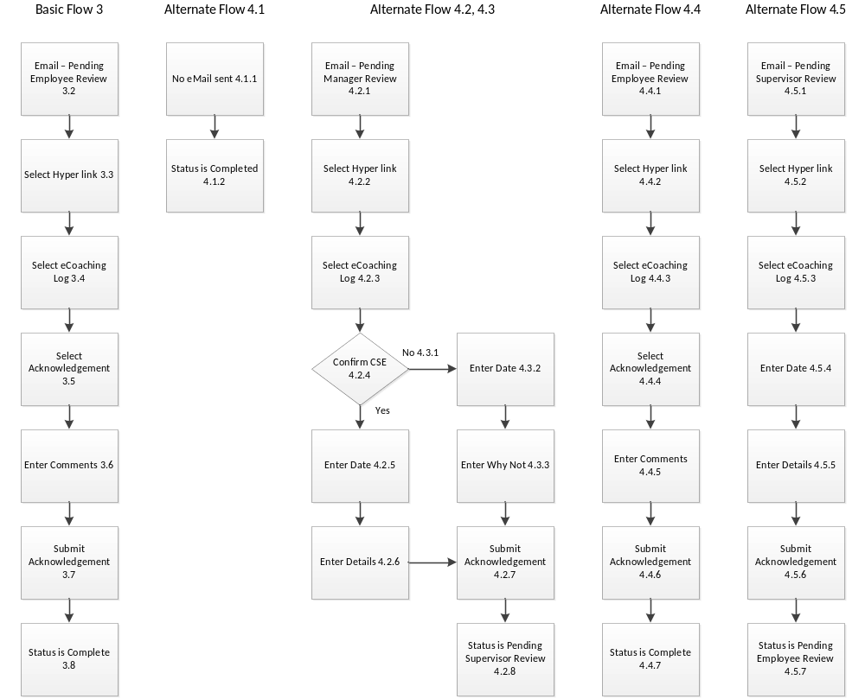

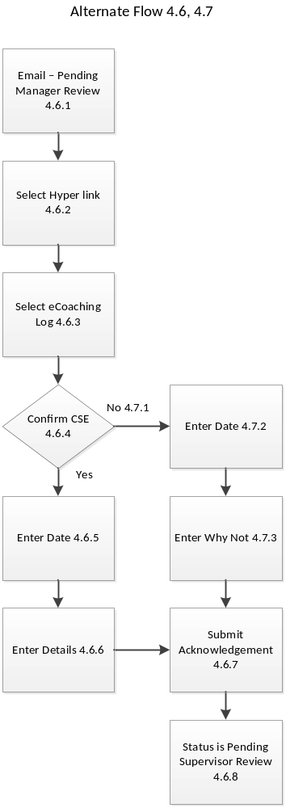

Figure 1 – CSR eCL Notification

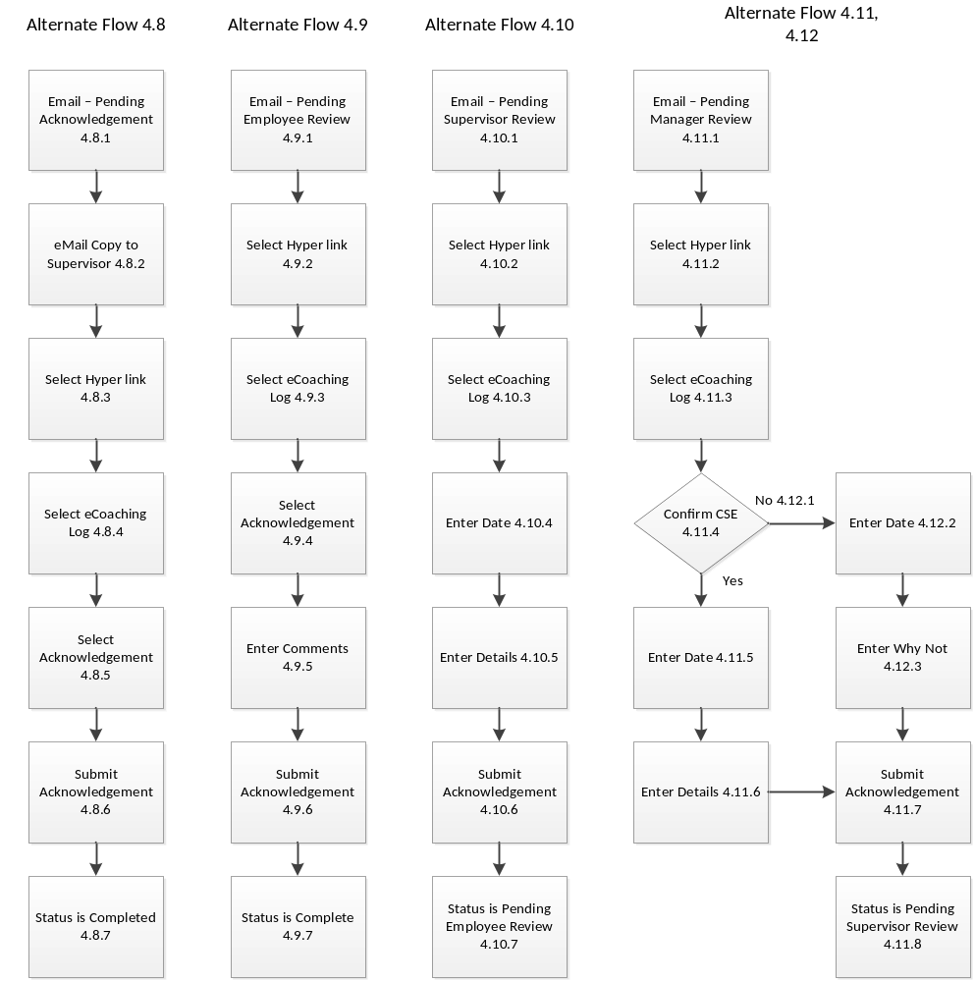

Figure 2 – CSR eCL Notification – Outlier

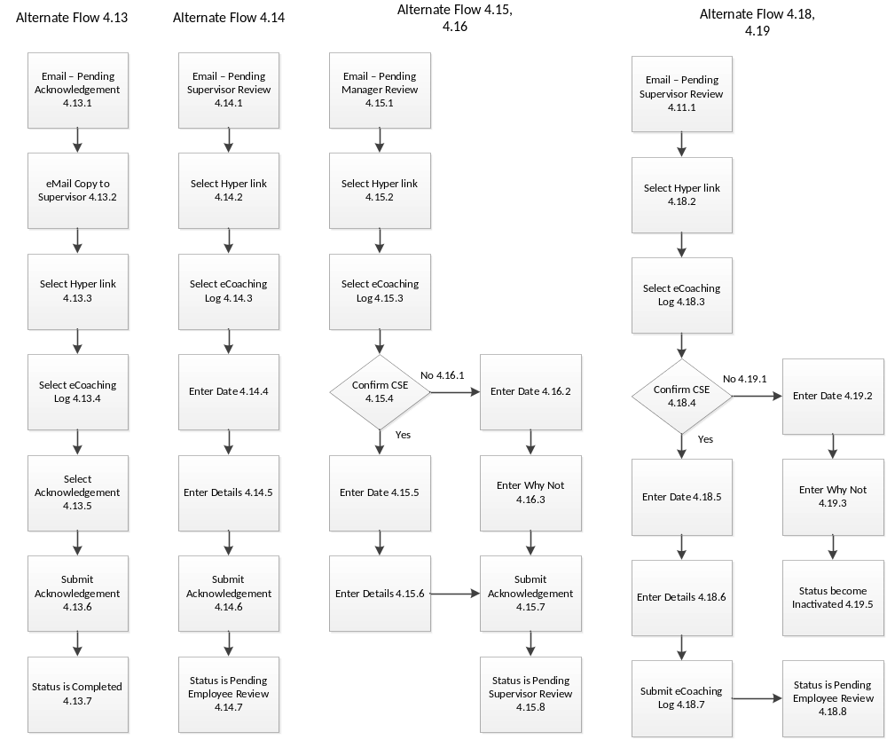

Figure 3 – CSR eCL Notification – IQS/Outlier

